Welcome to Acme Corp!

This document will guide you through the installation process of your virtual machines using Oracle Virtual Box.

1. Open Virtual Box. You should see it pinned to the task bar on your system.
2. Locate the folder labeled ISO files on your desktop.

The first virtual machine you will configure will use CentOS for the operating system.

1. To start the creation of a new VM select “machine”, then “new” from the upper task bar. You may also click the blue button found in the top middle of Virtual Box labeled “new”. This will spawn a window as shown below.

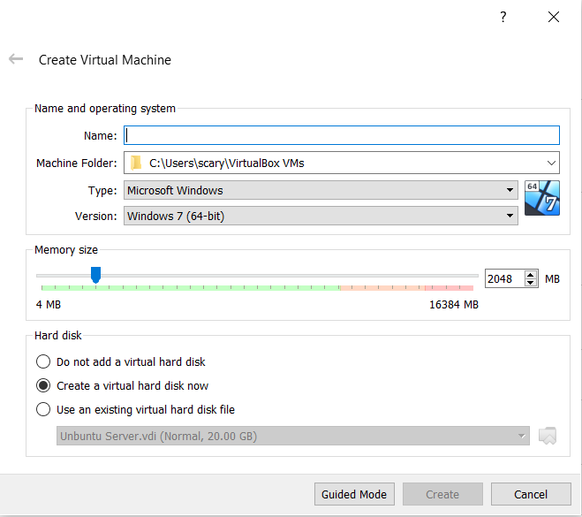

1. Name the operating system “CentOS”. This will automatically change the “Type” to “Linux”, and the “Version” to “Red Hat (64-bit). If it does not, please use the drop down menu for each field and change it accordingly.
2. Set the memory size to 2GB or 2048 MB.
3. Ensure the “Create a virtual hard disk now” radio button is selected and click the “create” button. The following window will open.

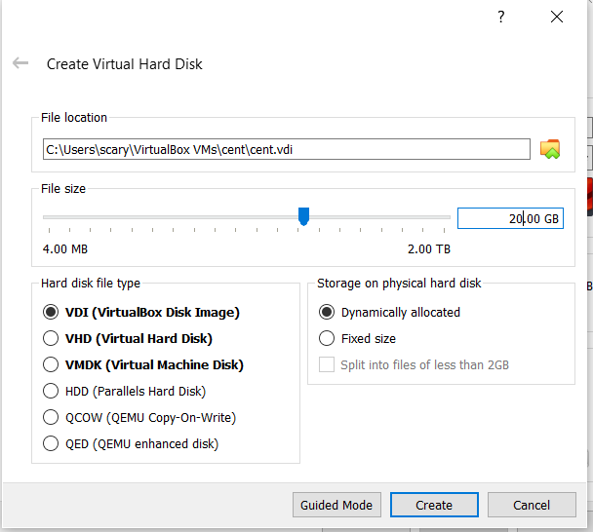

1. Under Hard disk file type, select “VDI (VirtualBox Disk Image)”. Under Storage on physical hard disk, select “Dynamically allocated”. Set the file size to 20.00 GB. Click create.
2. You will now see your virtual machine in the left hand panel within virtual box. Highlight your newly created VM if it is not already and review the general system information displayed.
3. Find and click on the “Network” section. The following window will open.
4. Ensure that the “Enable Network Adapter” box is checked and set the “Attached to” field to a Bridged Adapter. Then click ok.
5. Click the start button to power on your virtual machine.
6. A new window will spawn asking you to select a start-up disk.

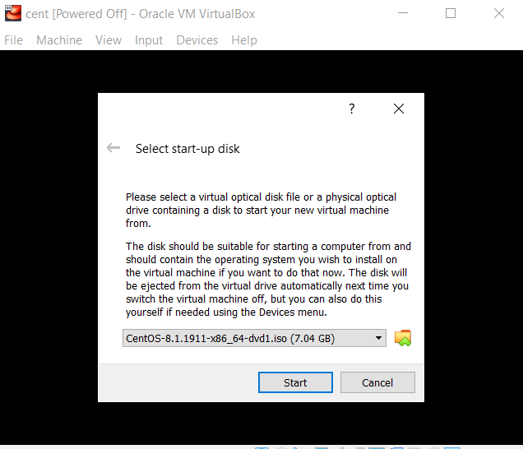

1. Select the CentOS ISO image from the ISO folder we located in step 2 and click start.
2. Using the arrow keys highlight the “Install CentOs Linux”.
3. Select the appropriate language.
4. Once you reach the “Installation Summary” window, you will need to address anything that has been flagged with the yellow caution symbol.
5. Verify the VDI image you created in step 7 is selected for the “installation destination”
6. Under Software, change the Software selection from “Server with gui install” to “Server”. In this window you can also select to install additional software. Please also select FTP server, Windows File Server, Headless management, Remote management for Linux. Note: These may also be installed after the initial installation is complete.
7. Begin the installation.
8. While installation is running you may set a root password, and create additional users if desired. For now just set a root password of “changeme”. This will be changed to something more secure at a later time.
9. Once the installation is complete, the VM will reboot from the iso image.
10. Power off the virtual machine, and locate the “Storage” field from the displayed settings.
11. Remove the ISO image from the optical drive. This will allow the VM to boot from the OS we just installed on our disk image.
12. Start the CentOS VM and login with the root user and changeme credentials you set during the install.
13. Your installation is now complete.

For installation of Unbuntu server the process will essentially be the same.

1. Repeat steps 1-3 above.
2. Name the vm “Unbuntu Server”, set the “Type” to Linux, and the “Version” to Unbuntu 64-bit.
3. Set the memory and virtual hard disk to the same capacity as your CentOS VM. 2GB or 2048MB for the memory, and 20.00GB for the virtual disk.
4. Verify the network adapter is enabled and set “attached to” to bridged. (see step 10. Above).
5. Start the virtual machine.
6. Select the Unbuntu Server ISO image from the ISO folder located on your desktop.
7. Once the install GUI loads, you can simply hit enter until you reach the “Filesystem” setup screen. See image below.

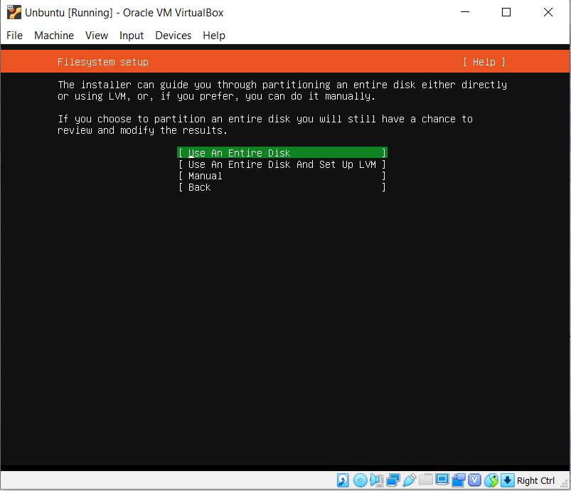

1. On this screen ensure “Use an Entire Disk” is selected and press enter.
2. Ensure the virtual disk image we created when creating the VM is highlighted, and press enter.

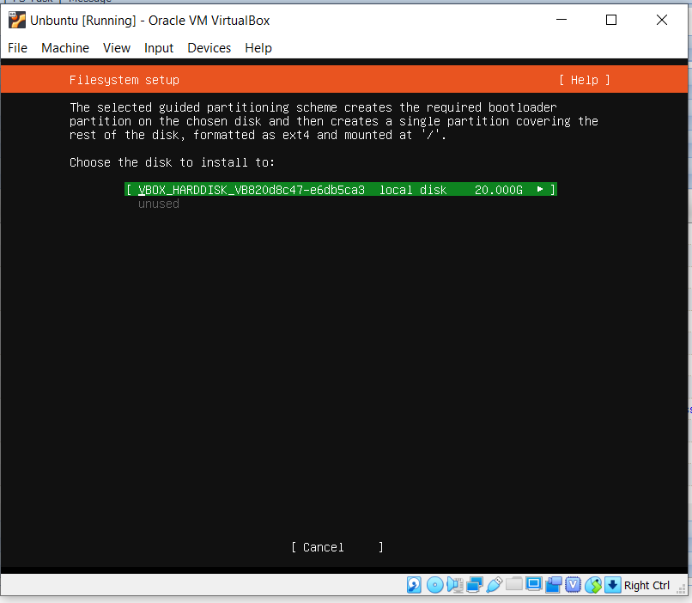

1. Enter the following for profile setup. Your name, Unbuntu Server for server name, first initial + last name for user name, set password to “changeme”. This will be changed to something more secure at a later time. Select done once you have completed filling in the profile setup.

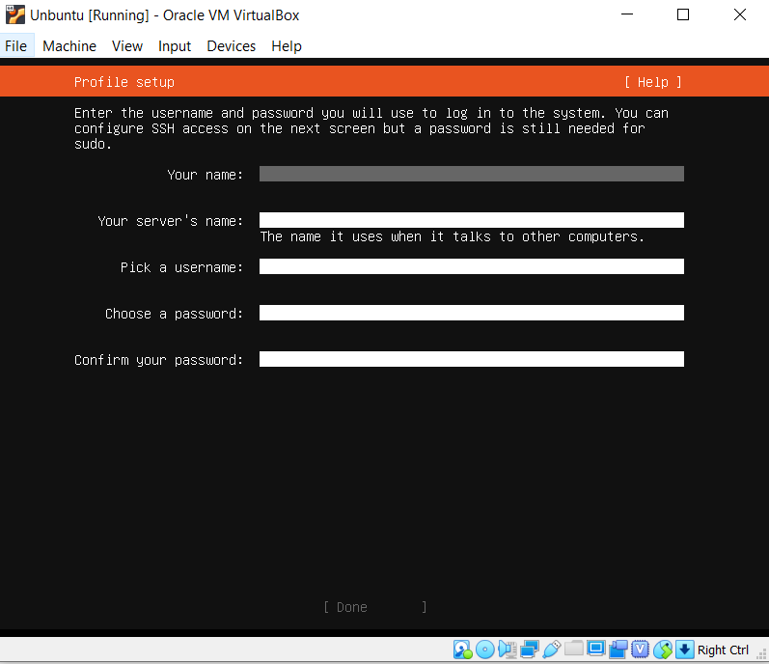

1. Hit the space bar to select installation of Openssh, and select done. The installation will now begin.
2. Once the installation is compete, select the storage and remove the ISO image from the optical drive. This will allow the virtual machine to boot from the newly installed OS.
3. Congratulations! You have successfully completed installation of your virtual machines.